**Name: Varad patil**

**Batch: A2**

**PRN:120A2036**

**EXPERIMENT NO. 07**

**RMS PULSE BROADENING DUE TO MATERIAL DISPERSION IN MULTIMODE STEP INDEX FIBER**

**EXPERIMENT NO. 06**

**RMS PULSE BROADENING DUE TO MATERIAL DISPERSION IN MULTIMODE STEP INDEX FIBER**

**OBJECTIVE:**

The objective of this experiment is to plot rms pulse broadening in a multimode step index fiber as a function of the optical source spectral width $σ_{λ}$ in the range 0.1 – 100 nm for peak operating wavelengths of 850 nm and 1300 nm, Let ∆=0.01, n1=1.46. Assume the factor $λ^{2}\frac{d^{2}n}{dλ^{2}}$ is 0.025 at 850 nm and 0.004 at 1300 nm.

**SOFTWARE USED: Python**

**THEORY:**

Chromatic dispersion or Intramodal Dispersion is the term given to the phenomenon by which different spectral components of a pulse travel at different velocities. To understand the effect of chromatic dispersion, we must understand the significance of the propagation constant β. We will restrict our discussion to single mode fiber since in the case of multimode fiber; the effects of intermodal dispersion usually overshadow those of chromatic dispersion. So the propagation constant β in our discussions will be that associated with the fundamental mode of the fiber.

Chromatic dispersion arises for two reasons.

1. The first reason is that the refractive index of silica, the material used to make optical fiber, is frequency dependent. Thus different frequency components travel at different speeds in silica. This component of chromatic dispersion is called material dispersion.

The rms pulse broadening due to material dispersion is given by,



The material dispersion for optical fibers is sometimes quoted as a value for |λ2(d2n1/dλ2)| or simply |(d2n1/dλ2)|.

However, it may be given in terms of a material dispersion parameter *M* which is defined as:



and which is often expressed in units of ps nm−1 km−1.

1. Although material dispersion is the principle component of chromatic dispersion for most fibers, there is a second component, called waveguide dispersion. To understand the physical origin of waveguide dispersion, we need to know that the light energy of a mode propagates partly in the core and partly in the cladding. Also that the effective index of a mode lies between the refractive indices of the cladding and the core. The actual value of the effective index between these two limits depends on the proportion of of power that is contained in the cladding and the core. If most of the power is contained in the core, the effective index is closer to the core refractive index; if most of it propagates in the cladding, the effective index is closer to the cladding refractive index.

The power distribution of a mode between the core and cladding of the fiber is itself a function of the wavelength. More accurately, the longer the wavelength, the more power in the cladding. Thus, even in the absence of material dispersion – so that the refractive indices of the core and cladding are independent of wavelength – if the wavelength changes, this power distribution changes, causing the effective index or propagation constant β of the mode to change. This is the physical explanation for waveguide dispersion.

**CODE:**

import numpy as np  
import matplotlib.pyplot as plt  
fac1 = 0.025  
fac2 = 0.004  
lam1 = 850  
lam2 = 1550  
c = 3*(10**8)  
sigs1 = []  
sigs2 = []  
M1 = (1/(lam1*c))*fac1  
M2 = (1/(lam2*c))*fac2  
sigl = np.arange(10, 100, 10)  
for i in range(len(sigl)):  
 sigs1.append(sigl[i]*M1*10**12)  
 sigs2.append(sigl[i]*M2*10**12)  
plt.plot(sigl, sigs1, label = ' sigl vs sigs1')  
plt.plot(sigl, sigs2, label = ' sigl vs sigs2')  
plt.xlabel("spectral width in nm")  
plt.ylabel("material dispersion n ps / ((nm*km)*10^12)")  
plt.legend()  
plt.show()

**OUTPUT:**

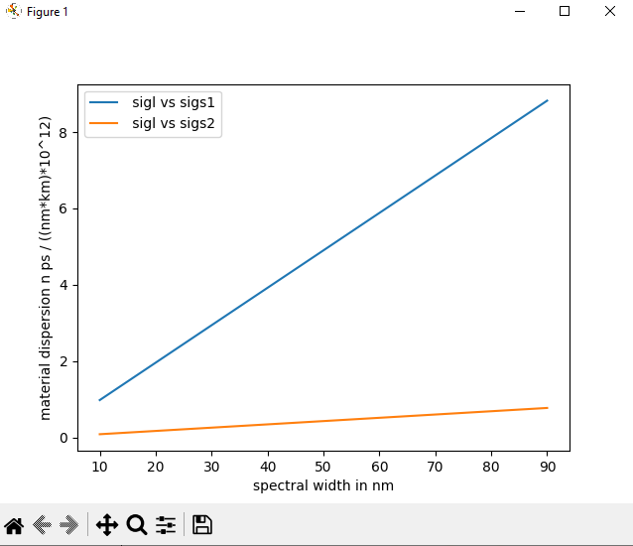

**CONCLUSION:**

As Spectral width increases material dispersion also increases. We can see that for different wavelength we get different material dispersion. For lower wavelength ie 850 we get more dispersion and for higher wavelength ie 1500 we get less dispersion. The experiment was performed successfully.